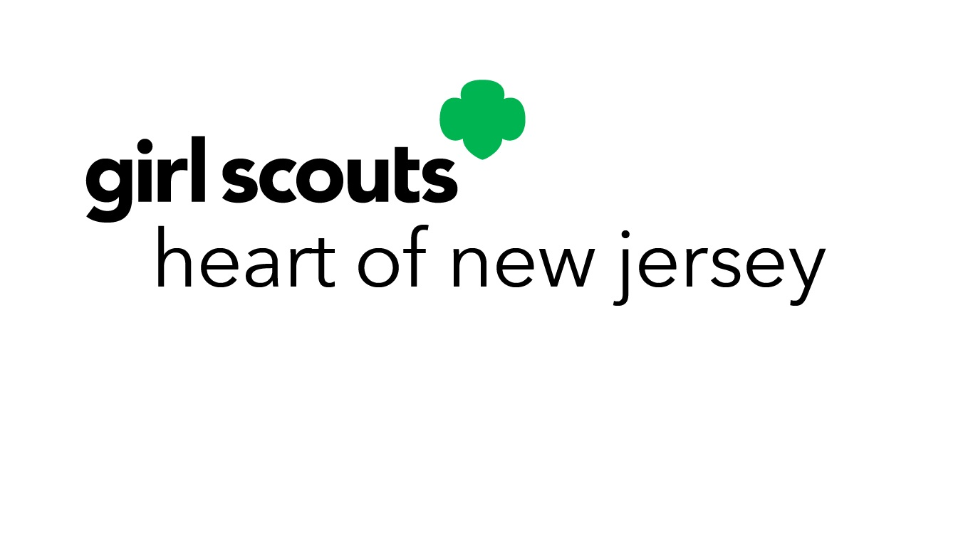

Thank you for including Girl Scouts Heart of New Jersey in your estate plans and ensuring the future of Girl Scouting.

This form lets us know of your decision to include Girl Scouts Heart of New Jersey in your will or estate plans and allows us to recognize you as a Juliette Gordon Low Society member.

Please complete the following information:

Name: ___________________________________________________________________________________

Address: _________________________________________________________________________________

City/State/Zip: ____________________________________________________________________________

Phone: _______________________________ Email: _____________________________________________

My gift to Girl Scouts Heart of New Jersey is: _________________________________and is intended as follows:

Unrestricted – may be used in any manner considered necessary by the Board of Directors.

Designated specifically for: _____________________________________________
(Camp/ Property/ Need)

Not yet designated; please contact me to discuss options for designating my gift.

I/We wish to be referred to as:

___ __________________________________________________________________________(name)

___ Anonymous and do not wish to be recognized publicly at this time.

Please include my spouse (name)______________________________________________as a Juliette Gordon Low Society Member _____yes ____no

Signature__________________________________________________________ Date______________________

All information will be held in the utmost confidence at all times.

Please send the completed form to:
Girl Scouts Heart of New Jersey
Fund Development
Post Office Box 2429
Westfield, NJ 07090-2149

Questions? Please contact Lauren Pendergast at funddevelopment@gshnj.org or 908-518-4414

